Line Manager Custom Role Redwood issue & other Issues
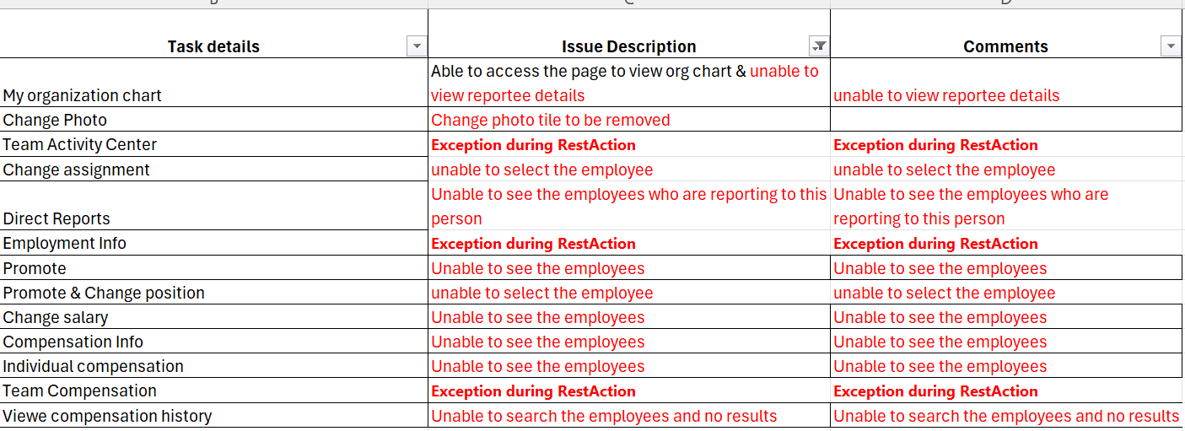
Issue 1:
Step 1:
Logged in as a Line Manager
While trying to select the organization chart( self or direct reports) the below error occurs
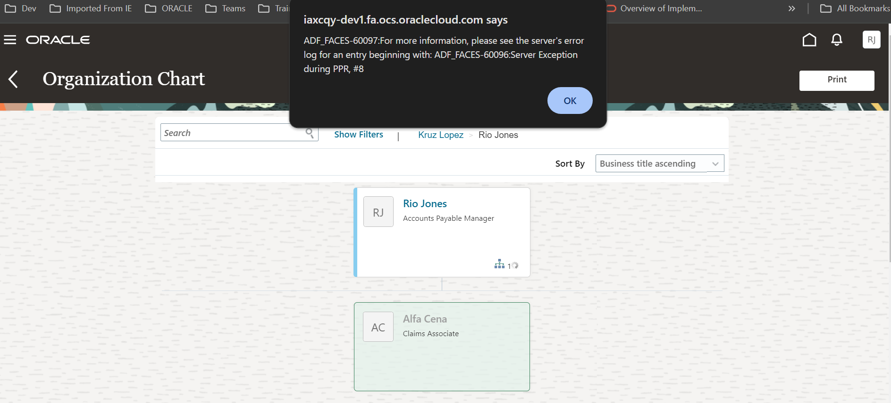
Issue 2:
While trying to perform the LM transaction like

Team Activity Center (Redwood Issue)
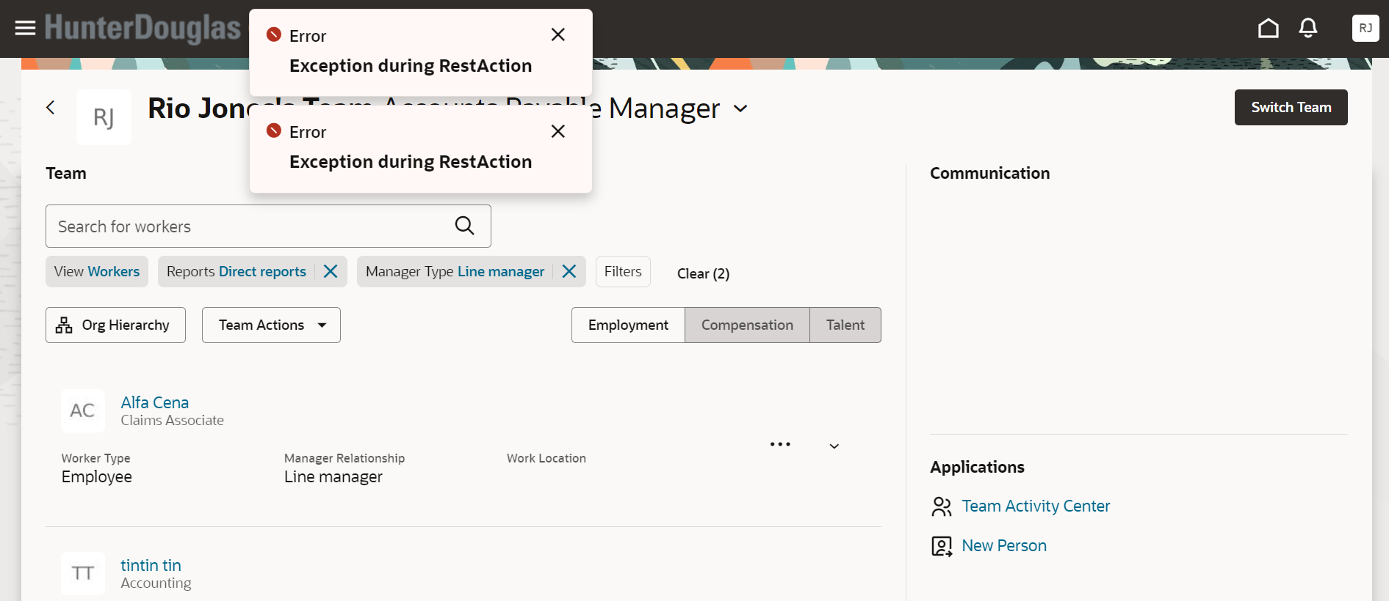
Change assignment:
When trying to select the employee name the transaction is not proceeding to the next page.
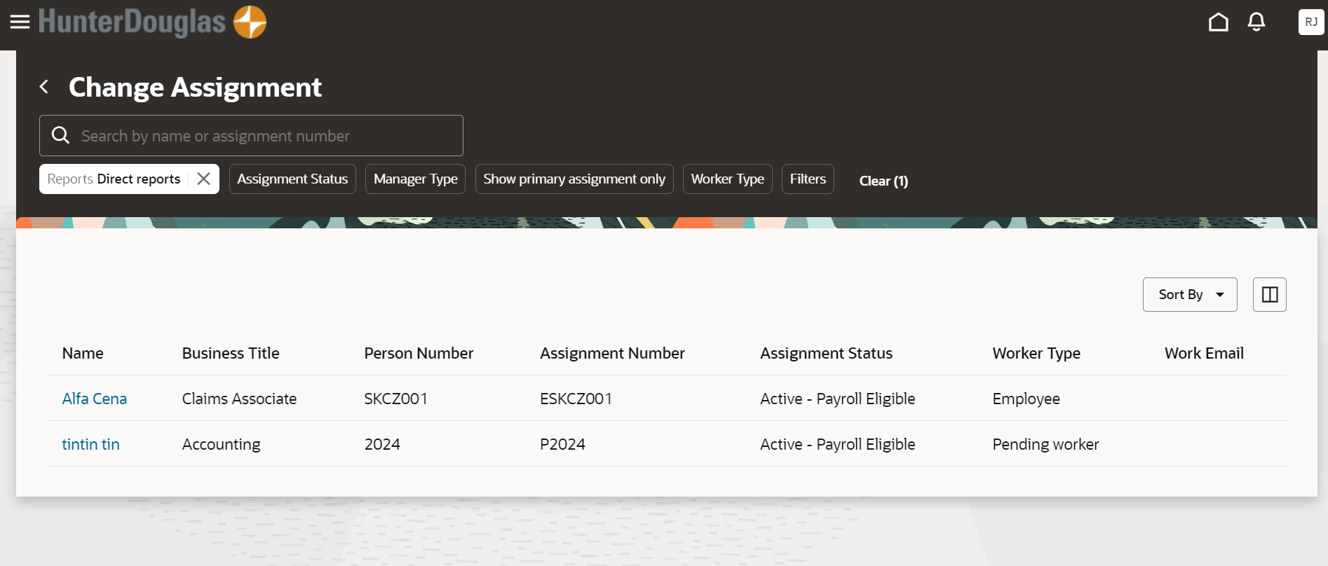

Direct Reports:
As per the below snippet , the LM is unable to see the Direct reports
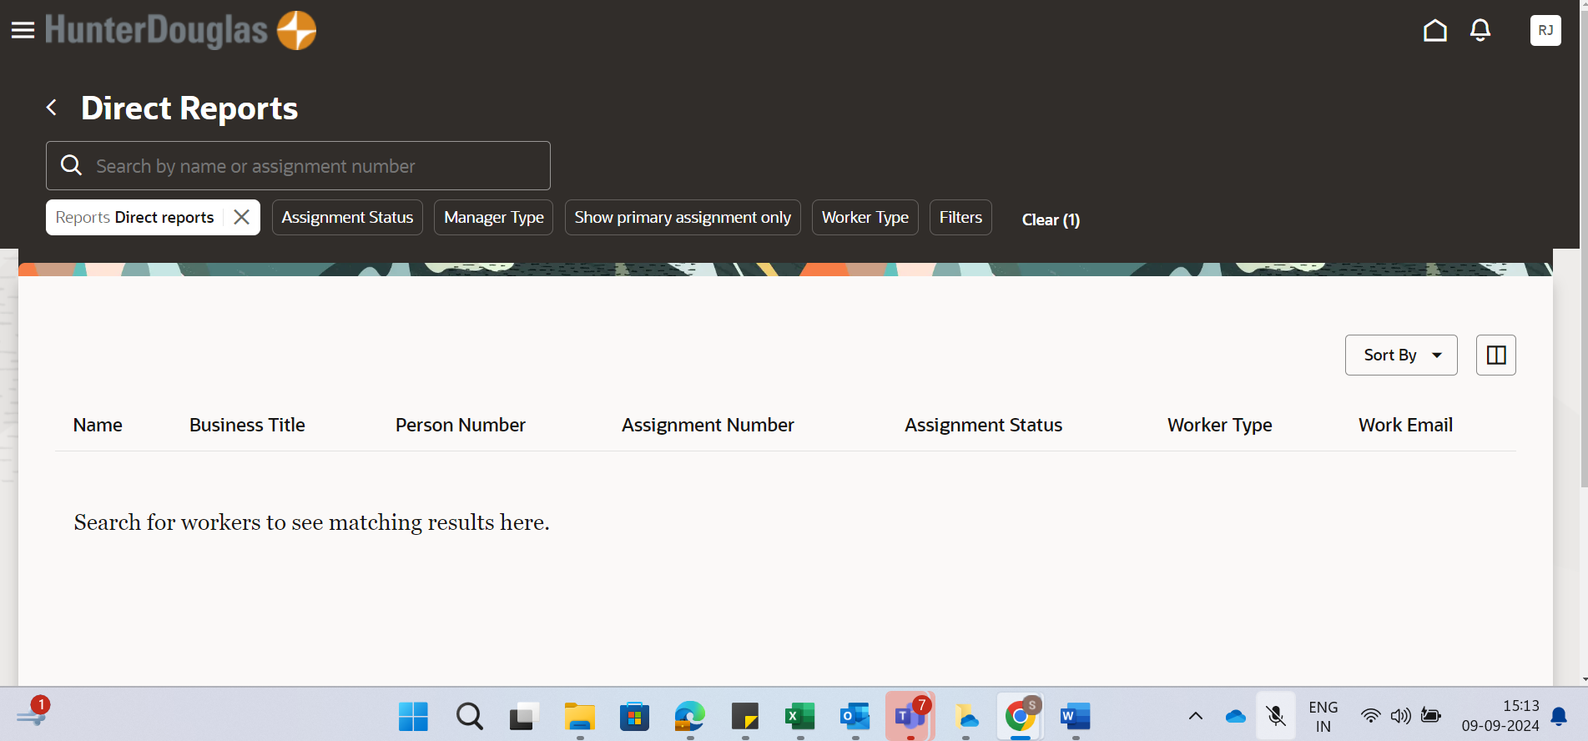
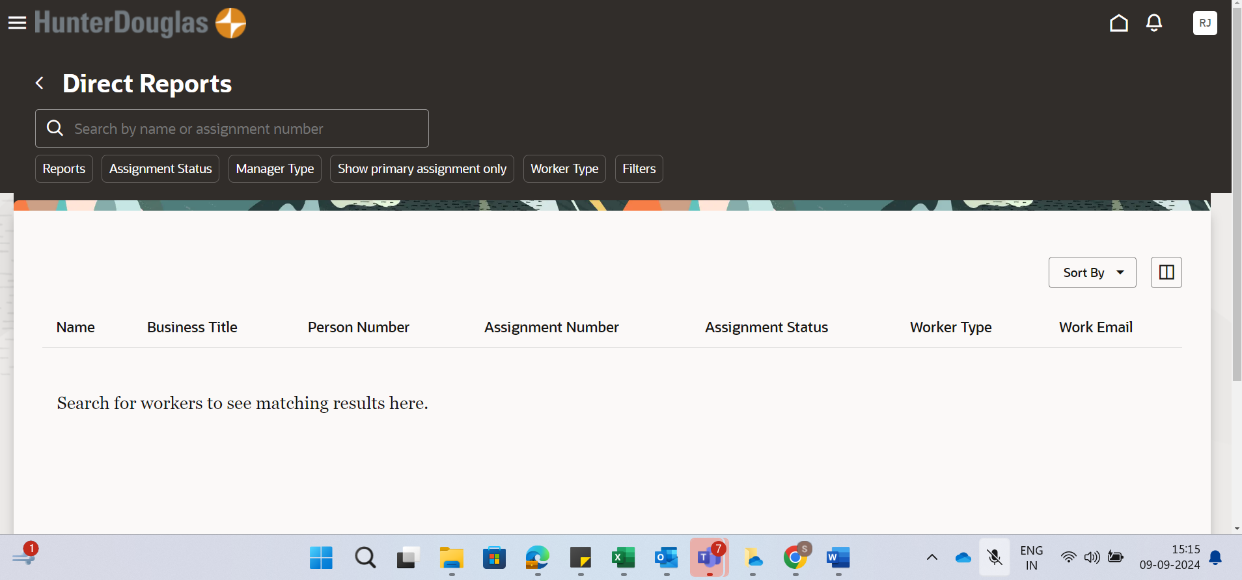

Promote:
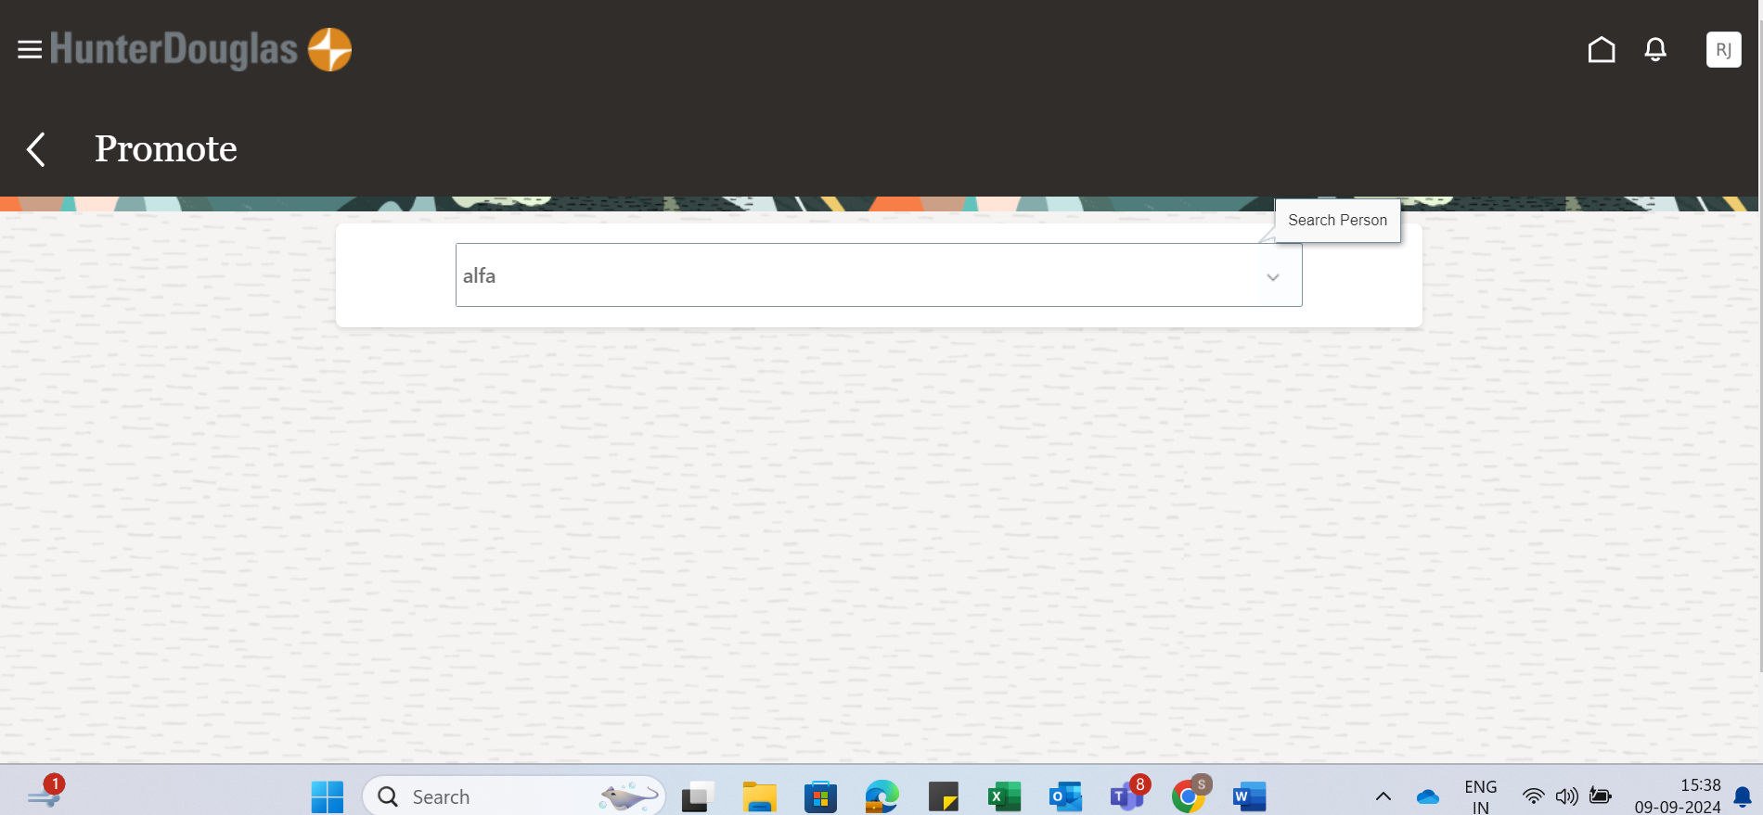

Promote & change position :
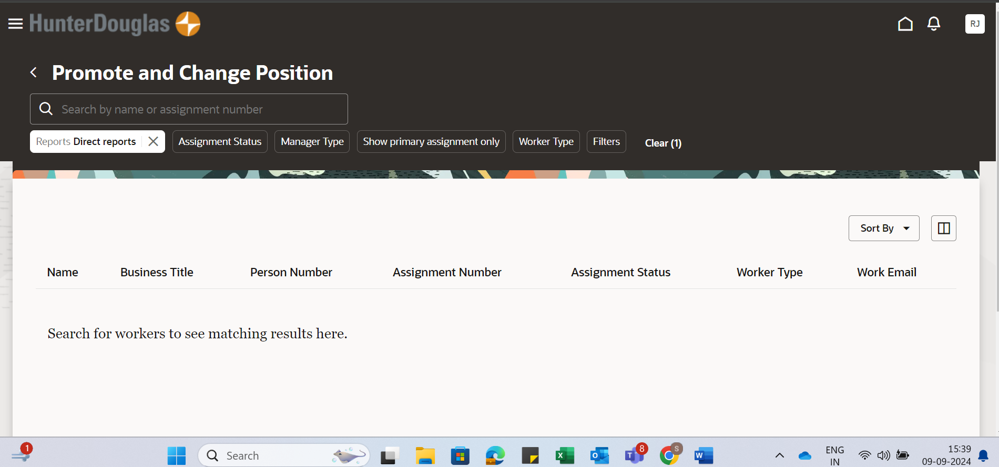

Change salary:
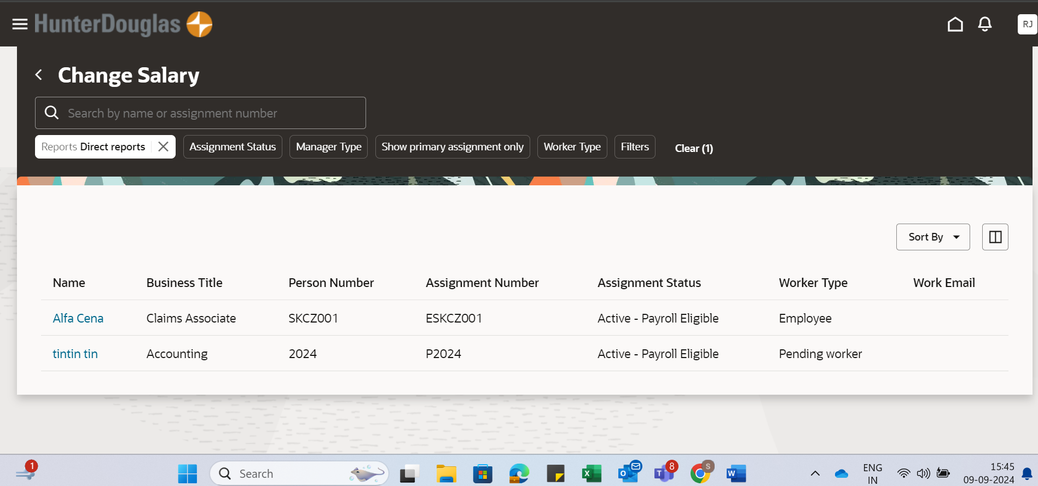
Seniority Dates:
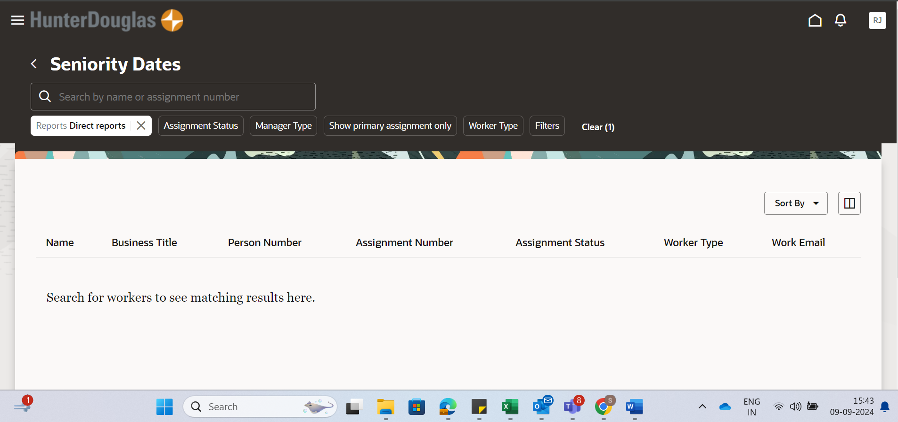

Compensation info:
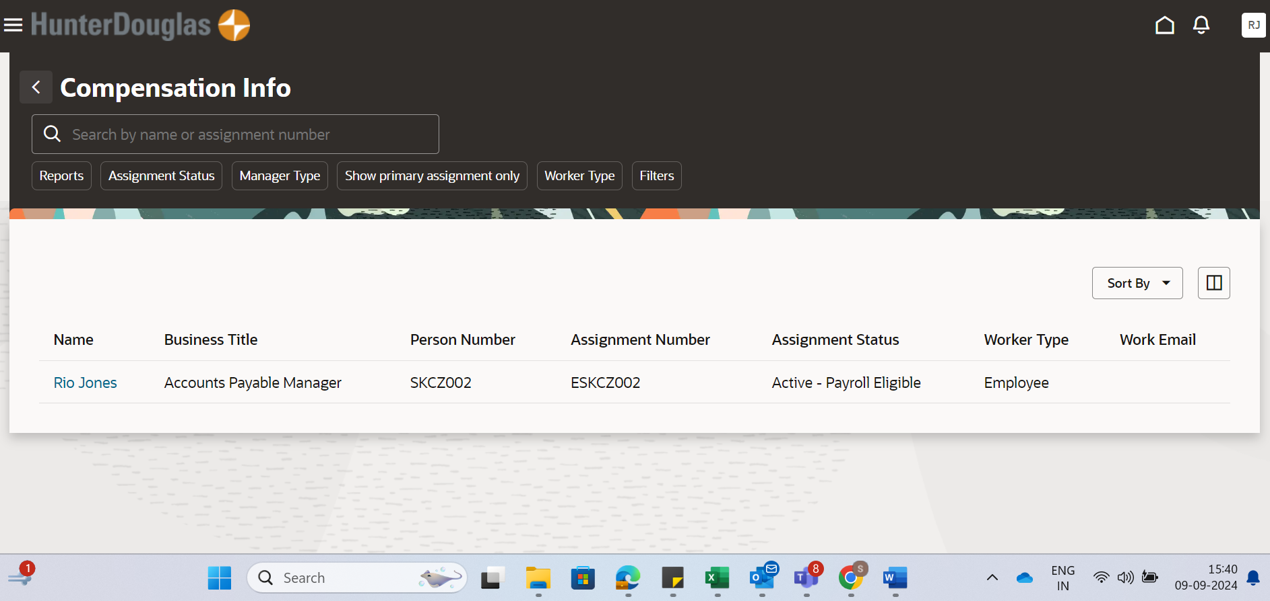

Individual Compensation:
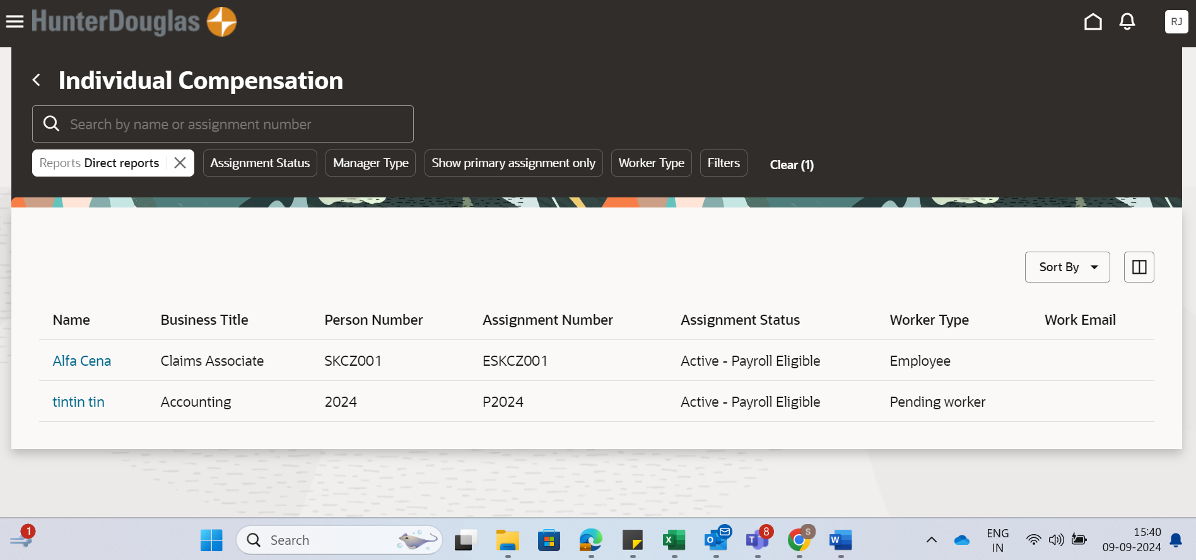

Team Compensation: (Redwood Issue)
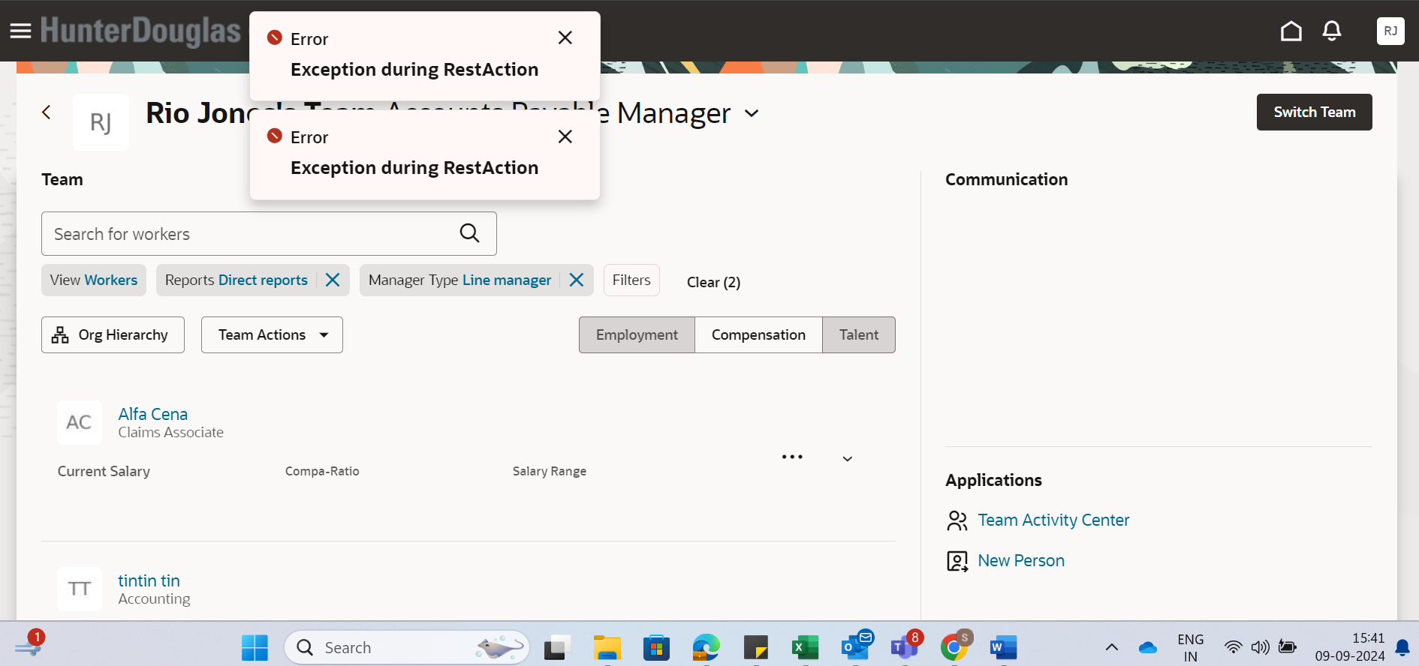
View Compensation History:
