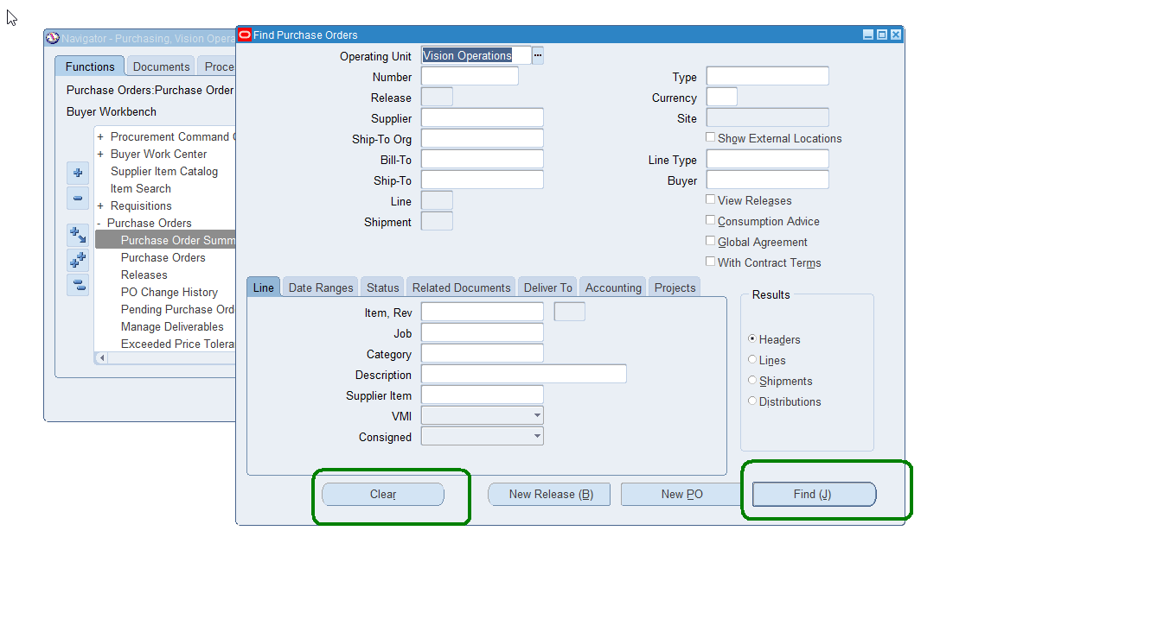
Clear and do an open search.
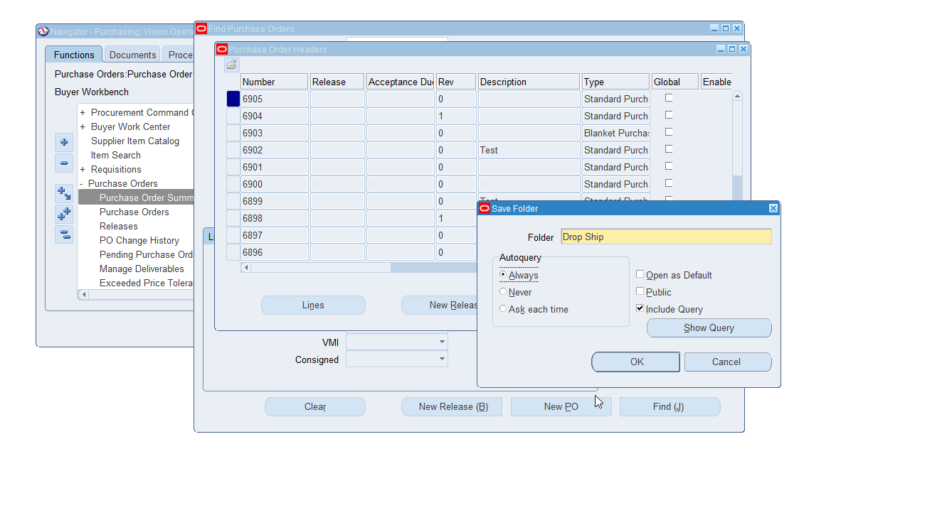
Created the folder.
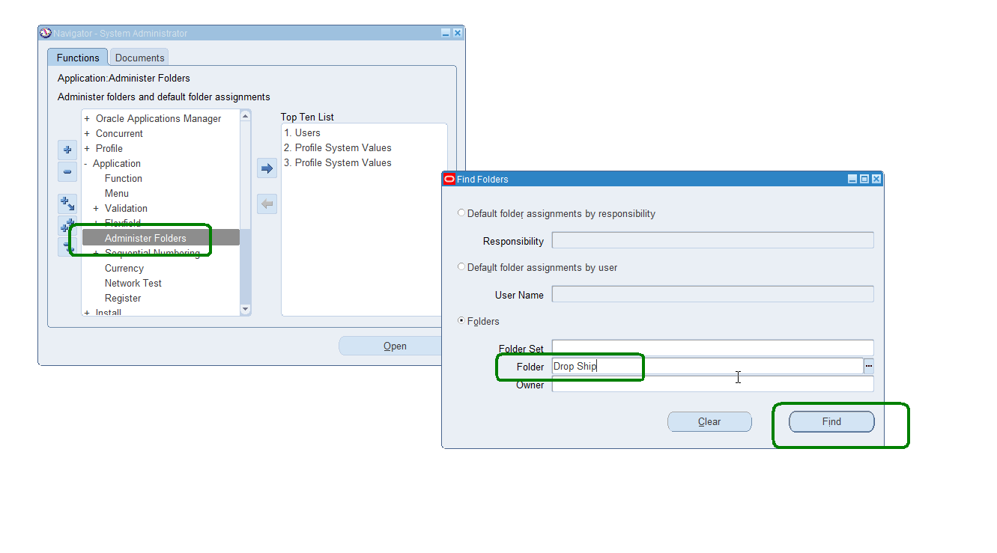
System Administrator – query the folder.
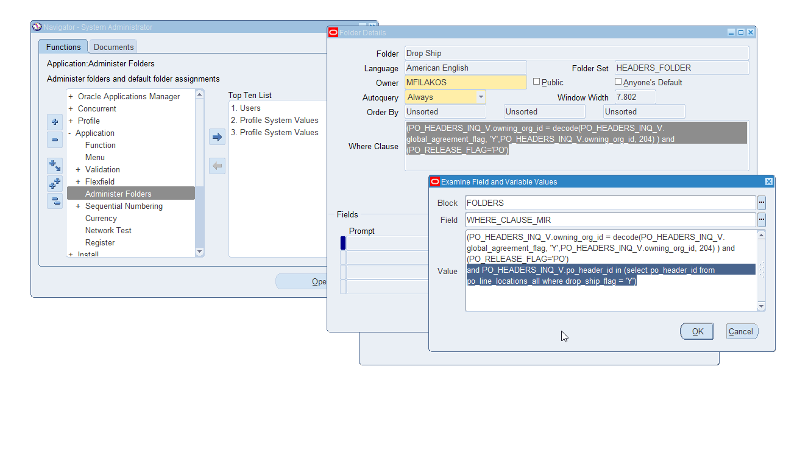
Use help/diagnostics examine – while cursor is in the where clause.
Modify the clause to now limit to drop ship – adding following.
and PO_HEADERS_INQ_V.po_header_id in (select po_header_id from po_line_locations_all where drop_ship_flag = 'Y')
choose OK then choose Save icon to save change.
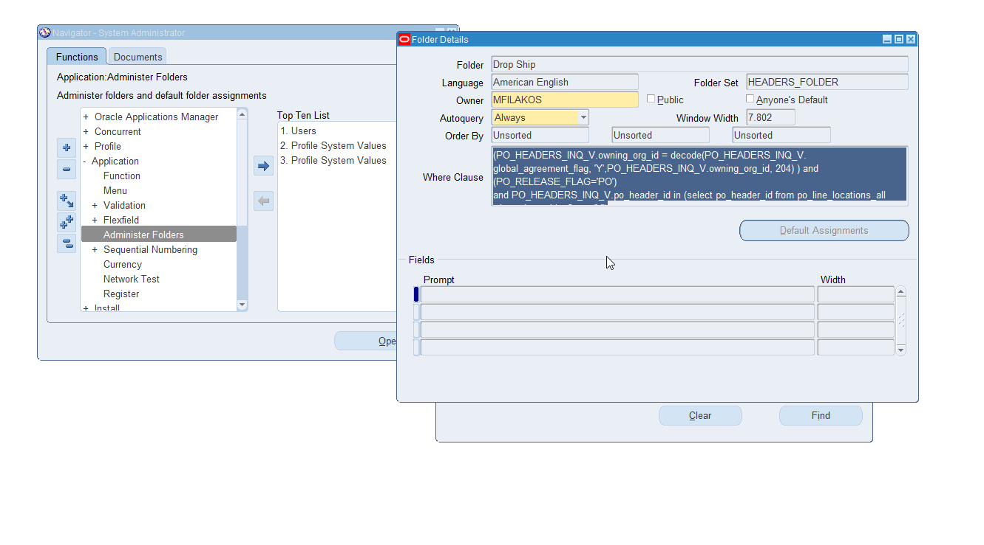

Back to po summary.
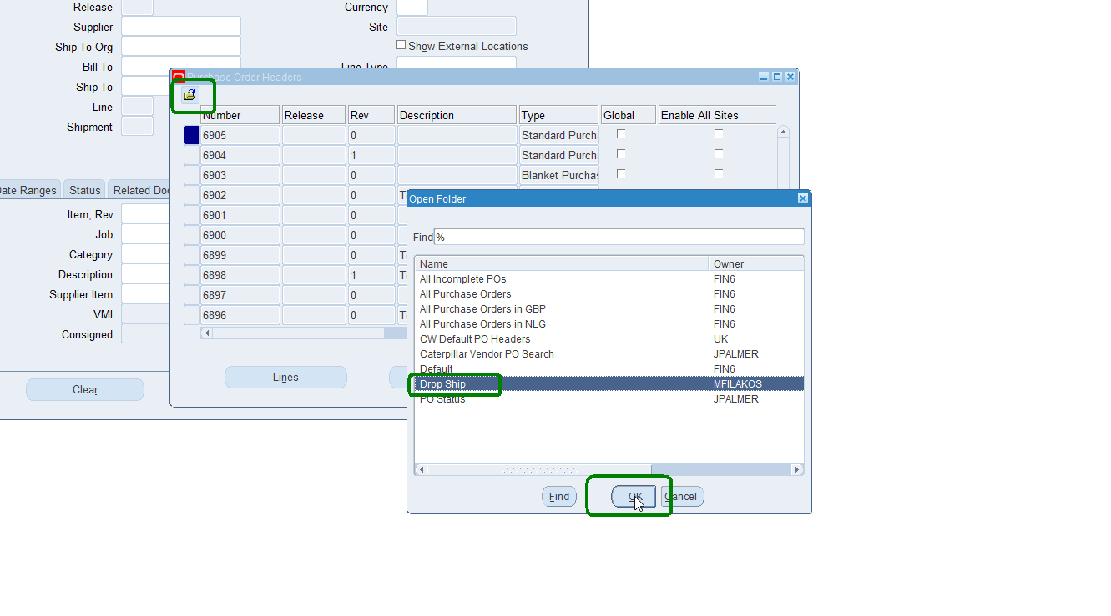
Folder icon – choose Folder
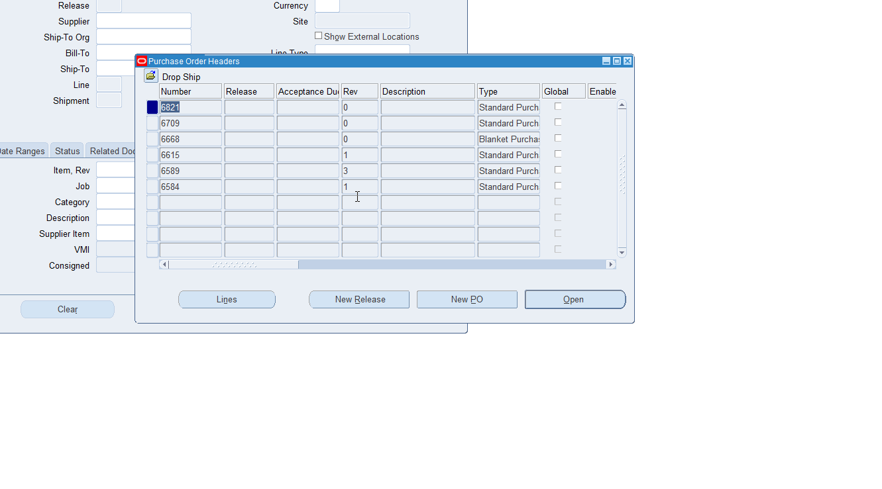
These are all drop ship based PO’s.

